EDA Important Points:



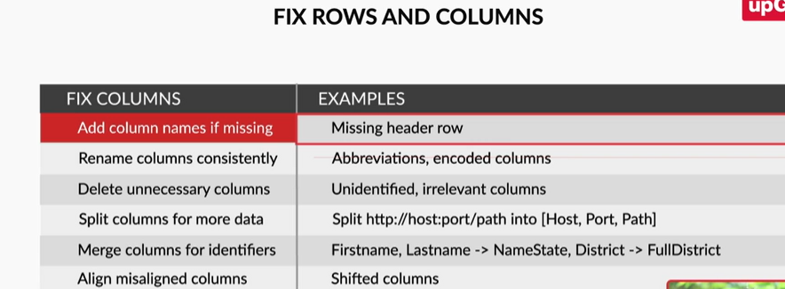

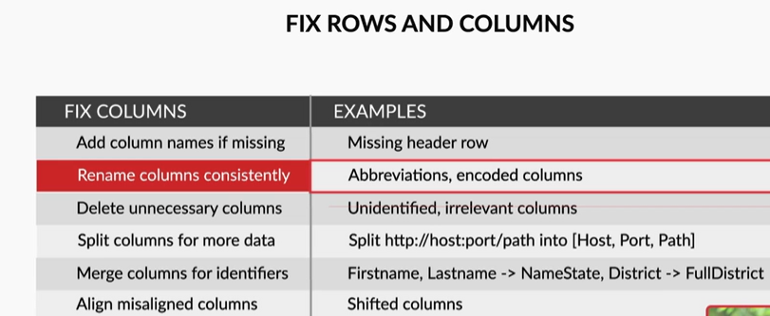

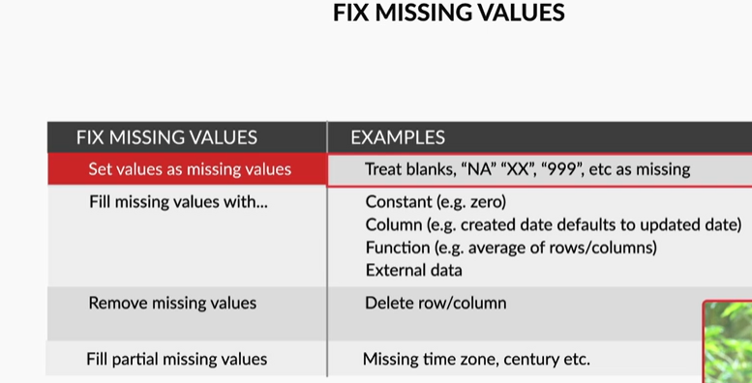

There are various ways to deal with missing values. Either you can drop the entries that are missing if you find that the percentage of missing values in a column is very small, or you can impute the missing values with some other values. Let us look into the various ways to impute the missing values.

Imputation on categorical/numeric columns:

Categorical column:

Impute the most popular category.

Imputation can be done using logistic regression techniques.

Numerical column:

Impute the missing value with mean/median/mode.

The other methods to impute the missing values involve the use of interpolation, linear regression. These methods are useful for continuous numerical variables.